**Odoo-Quickbooks Online Connector User Manual**

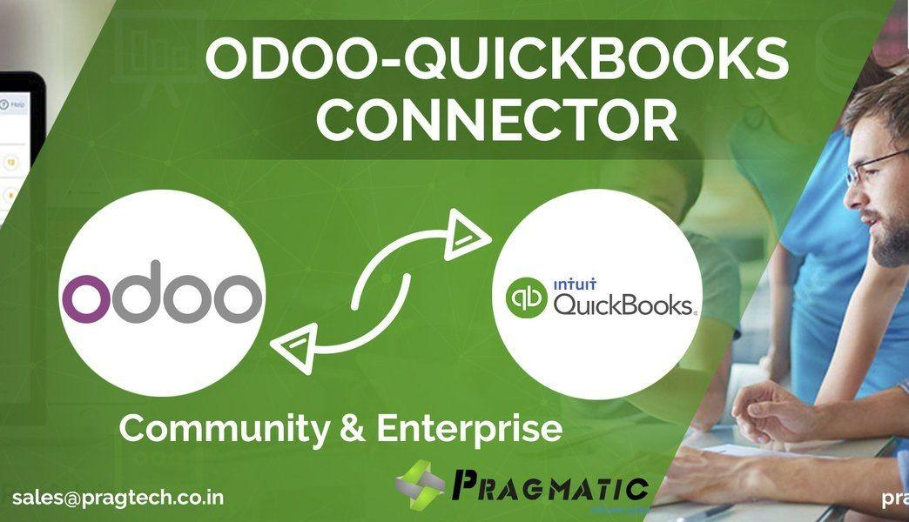

* **Quickbooks Interface:-**

**Step 1:** Go to [https://developer.intuit.com](https://developer.intuit.com/) and click **signin** menu. Fill username and password and click on **signin** button (If you are already have an Account or else continue with Signup process)

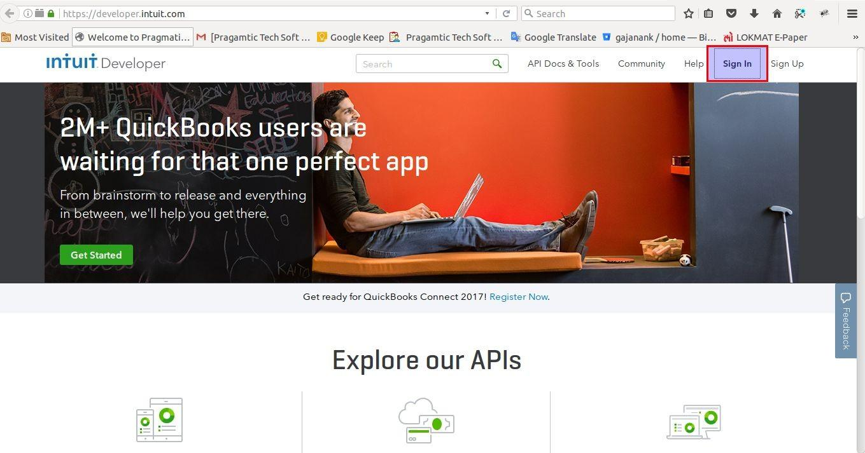

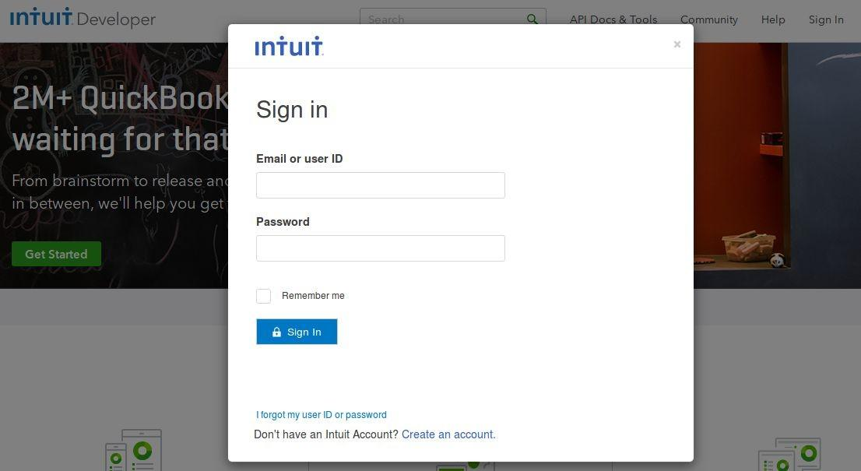

**Step 2:** After successful login, click **My Apps** menu then click **Create new app** button. Go to just start coding section and click **Select APIs**.

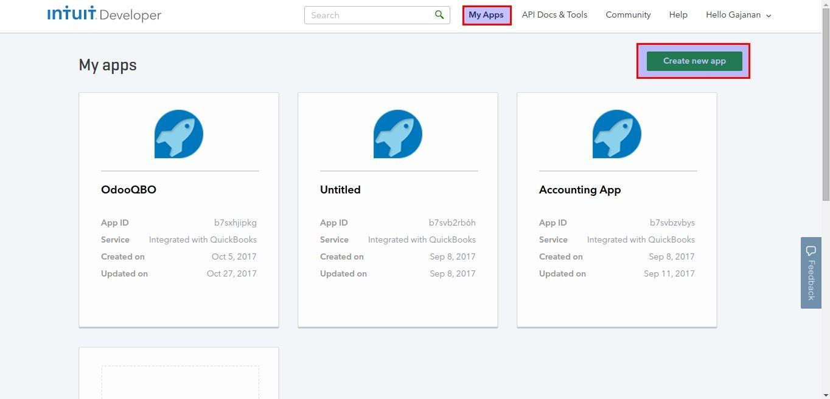

**Step 3:** Check Accounting and create new accounting app by clicking on **Create App** button.

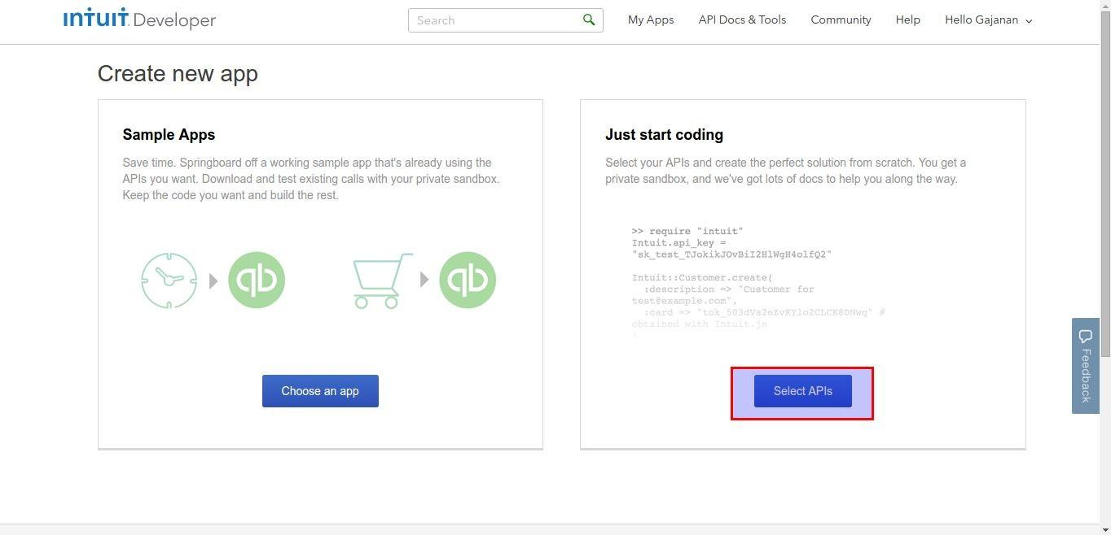

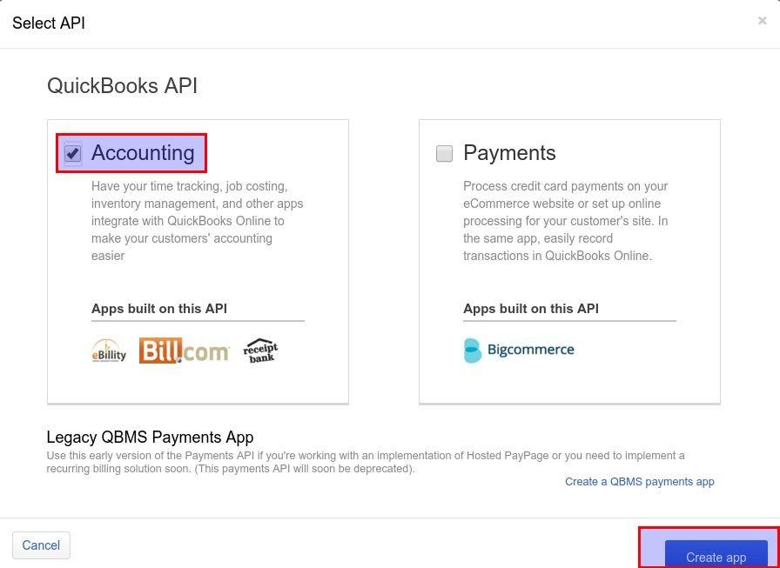

**Step 4:** Select **Keys** menu, you will get all the keys from the page. Create redirect URL with your domain suffix with **/get_auth_code.**

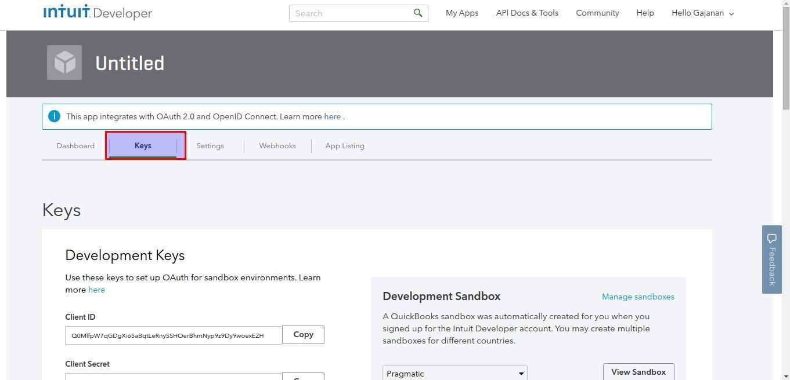

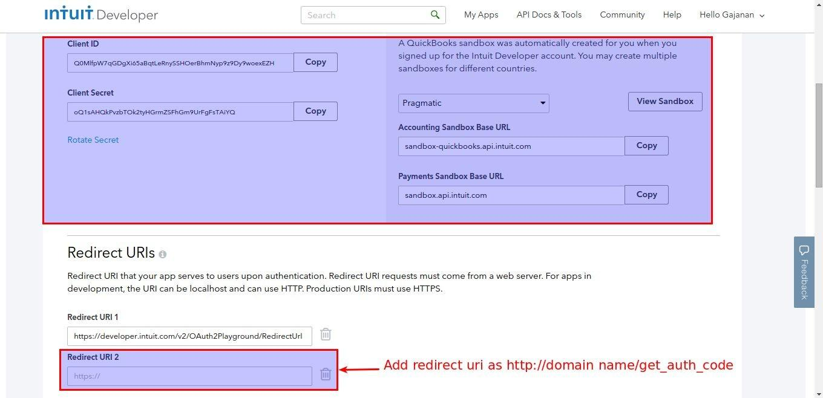

* + Odoo Interface:-

**Step 5:-** Sign In to Odoo Admin Account -> Go to Settings -> Companies

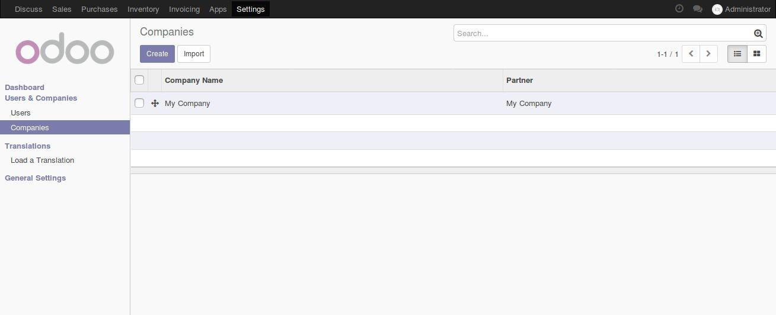

**Step 6:-** Click on company name as per requirement -> Select Quickbooks Menu

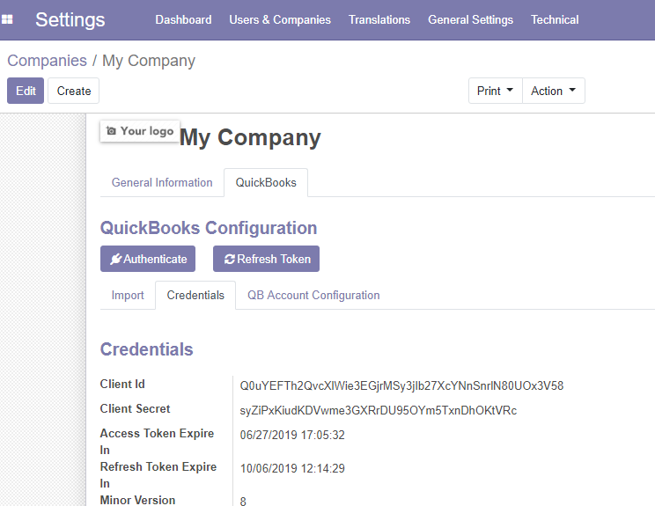

**Step 7:-** Inside Quickbook configuration you can see three tabs named as

**Initial Sync, Credentials and QB Account Configuration**. Go to Credentials tab and Paste the credentials for Client Id and Client Secret copied from Quickbooks to respective fields in Odoo under it.



**Step 8:**- Click on Authenticate.

**Authenticate:-** This button will check the credentials from both sides and if it matches, authentication get successful, only then it will give permission to sync the data.

**Refresh Token:-**

It will help to keep bridge between the Quickbooks and Odoo. If you have clicked then you don’t need to **authenticate** after every 2 hours to sync the data from functionality.

**Step 9**:-

**Last Imported Id:-**

This showcase the last imported id from Quickbooks to odoo which is to showcase whether the data has been synced or not and the last id of same.

If you wish to **update** the data please follow below steps to update the data from quickbooks to odoo if there is any change in it.

* + 1. Settings -> Companies -> Select Company
    2. Click on Edit button
    3. Go to Quickbooks tab -> Initial Sync
    4. Set the data to ‘0’ from the last imported id (For example if Last Imported Id for Customer Sync is showing 301 then you need to make it 0 and again click on sync data)
    5. Save
    6. Sync

**Exporting Data from Quickbooks to Odoo:-**

The sync data in the defined sequence:-

1. Import Chart of Accounts
2. Import Accounts Tax

This is the base before the other master data to be pulled in.

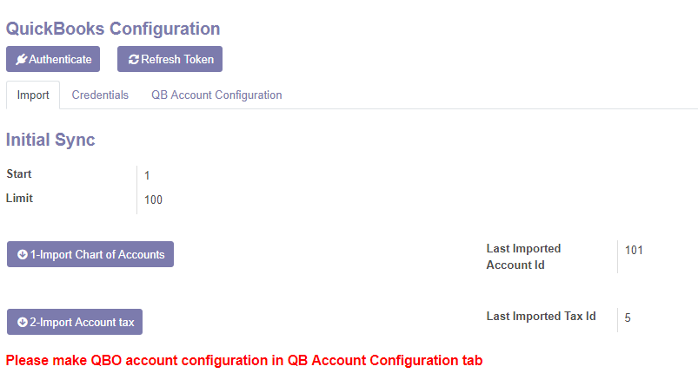

After these imports, there is one important configuration needs to be made in the **QB Account Configuration** tab.

Once that is imported, you can fetch further data in below sequence:-

3) Customer

4) Vendor

5) Product Category

6) Products

7) Inventory

8) Payment Method

9) Payment Terms

The Journal should be defined in Odoo against the Account used for payment in Quickbooks before import of other accounting entries else system will throw the below warning (For reference)

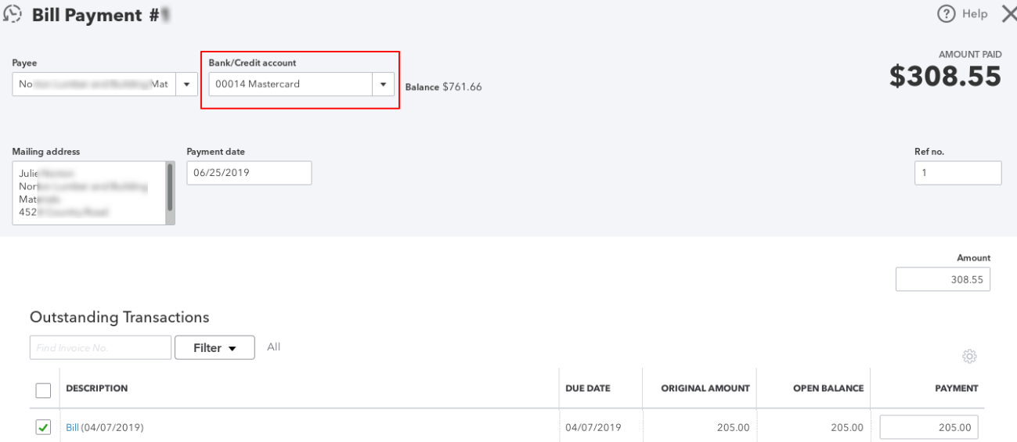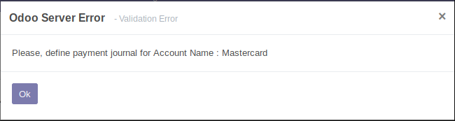

10) Sales order

11) Invoice

12) Purchase Order

13) Vendor Bills

14) Customer Payment

15) Vendor Payment

16) Department

17) Employee

**Exporting data from Odoo to Quickbooks:-**

**Goto ⇒ Settings⇒ Actions⇒ Server Actions**

In this Actions, you need to sync the data to be exported from Oddo to QB for Selected Master.

Server Actions enable the “Export to Quickbook” options in Action Item.

**Customer/Supplier Export:-**

To export customer/Supplier from odoo to quickbooks, click on the customer/supplier you want to export.

In customer/supplier form select Action button at the top. Then select Export to Quickbooks option in drop down menu and your customer/supplier get exported to QB successfully.

Similarly , if there is any change you have made in Odoo under Customer/Supplier then it can be successfully update in Quickbooks through this option.

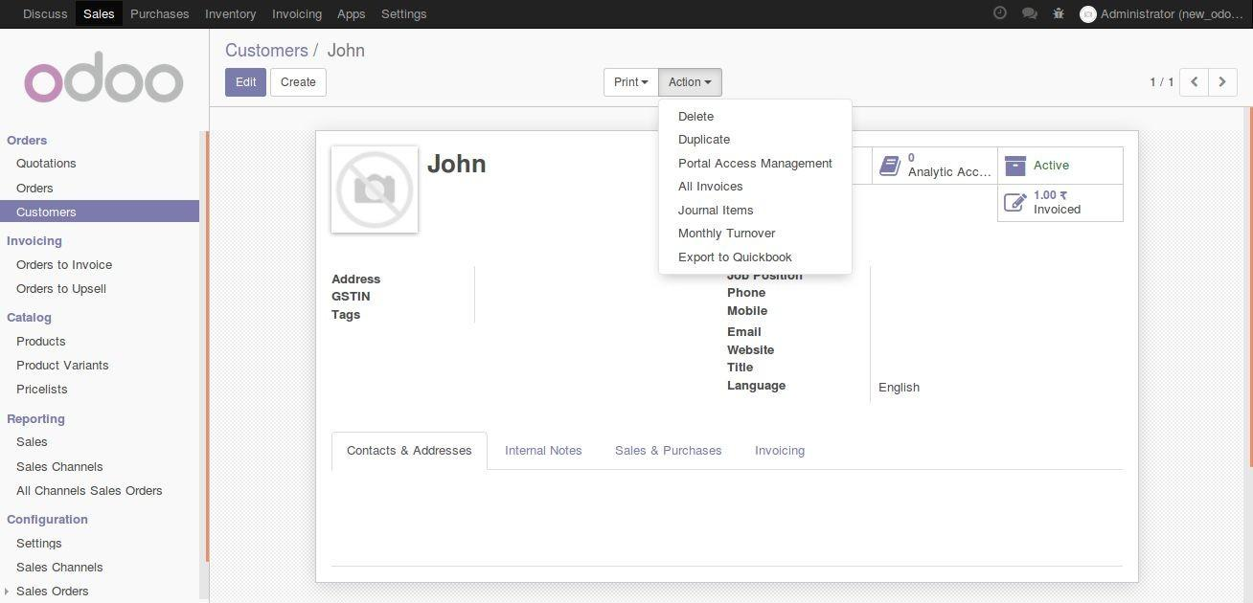

**Product Export:-**

To export product from odoo to quickbooks, click on the product you want to export. In product form select Action button at the top.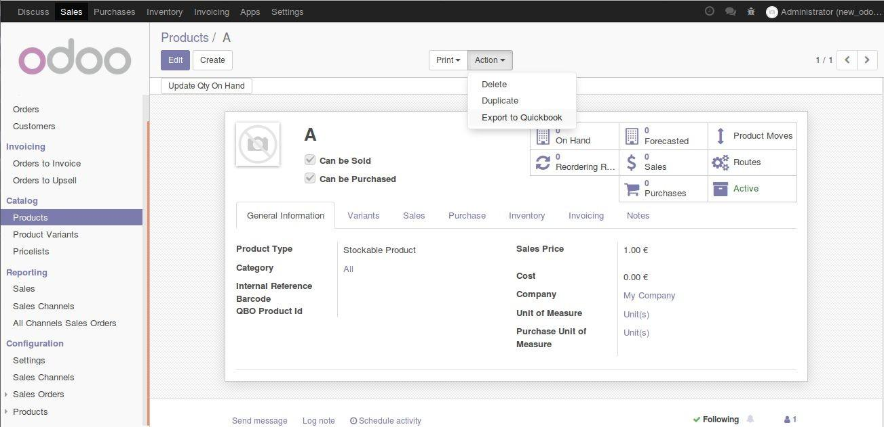

Then select Export to Quickbooks option in drop down menu and your product get exported to QB successfully.

**Customer Sale Order/Invoice Export:-**

To export customer sale order/invoice from odoo to quickbooks, click on the the customer sale order/invoice you want to export. In customer sale order/invoice form select Action button at the top. Then select Export to QBO option in drop down menu and your customer invoice get exported to QB successfully.

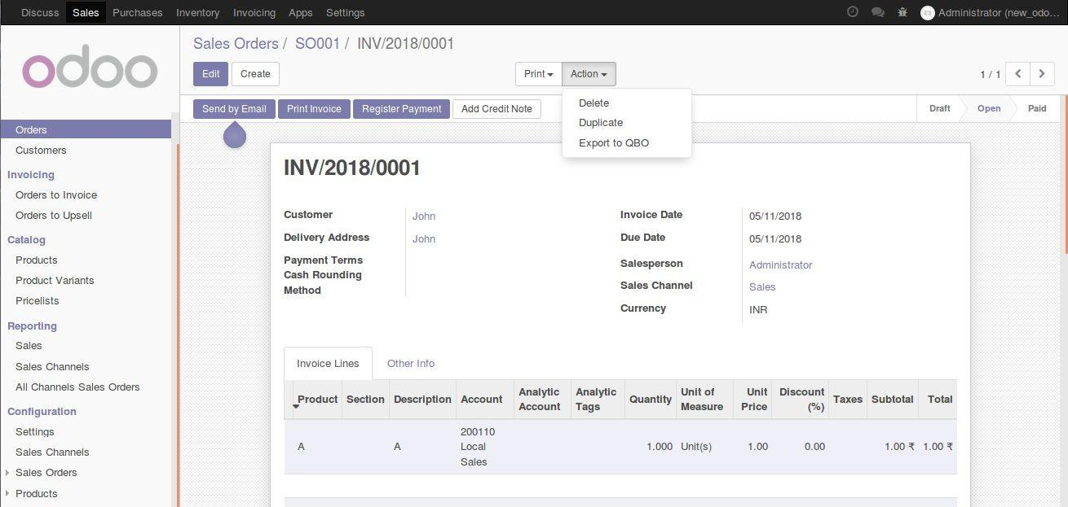

**Charts of Accounts Export:-**

To export **Charts of Accounts** from odoo to quickbooks, click on the the charts of account you want to export.

In charts of account form select Action button at the top.

Then select Export to QBO option in drop down menu and your charts of account get exported to QB successfully.

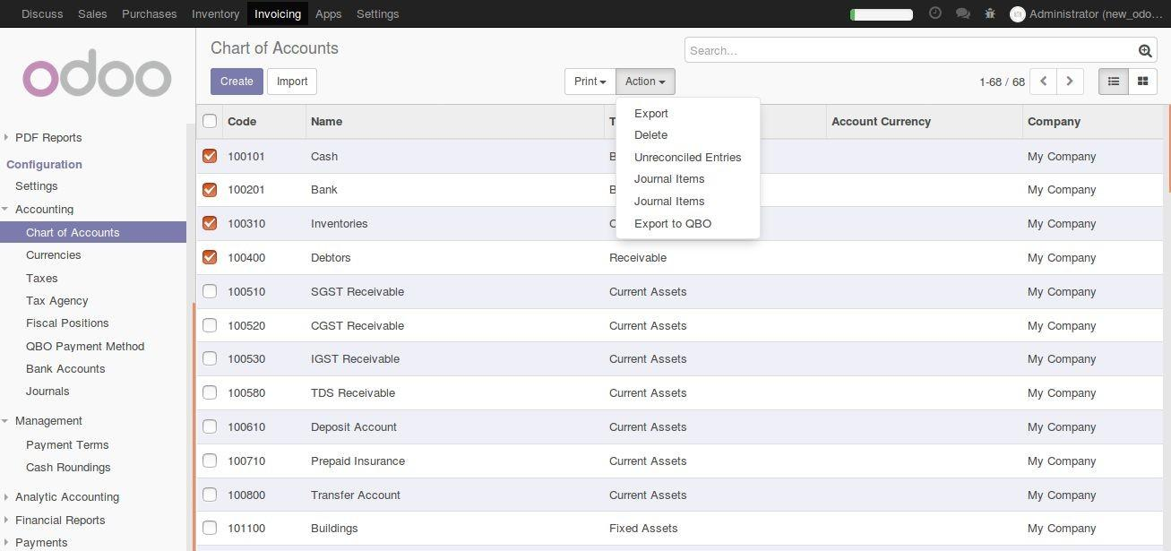

**Payment Terms Export:-**

To export Payment terms from odoo to quickbooks, click on the the Payment terms you want to export.

In Payment terms form select Action button at the top.

Then select Export to QBO option in drop down menu and your charts of account get exported to QB successfully.

